Yg mungkin gw tanya :
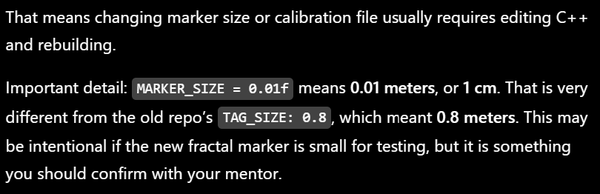



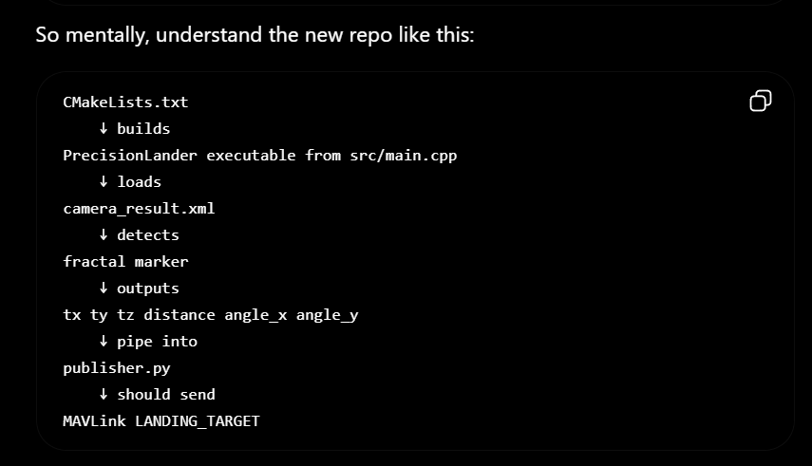

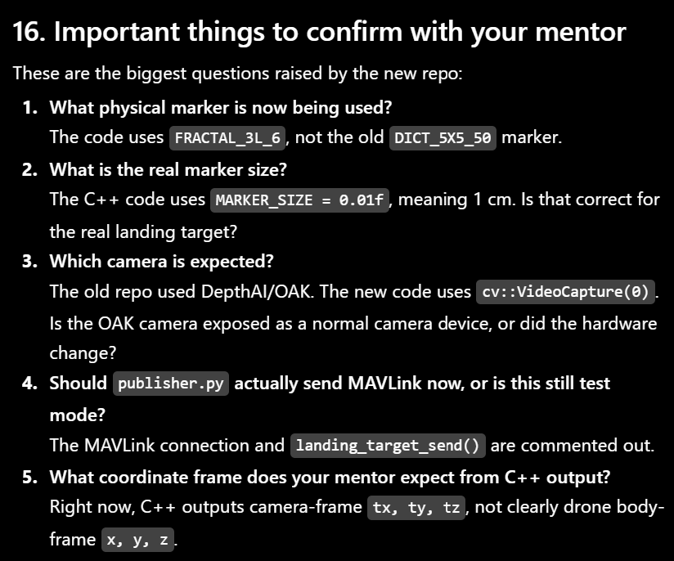

About camera calibration:
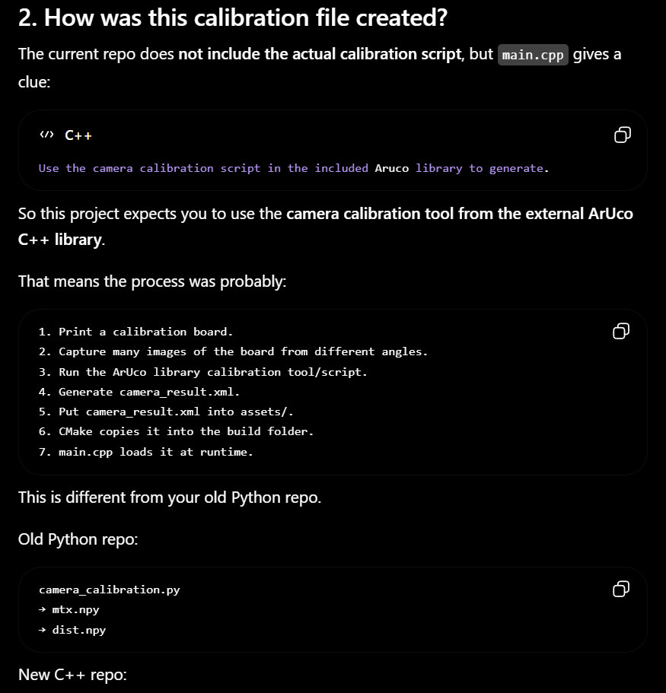
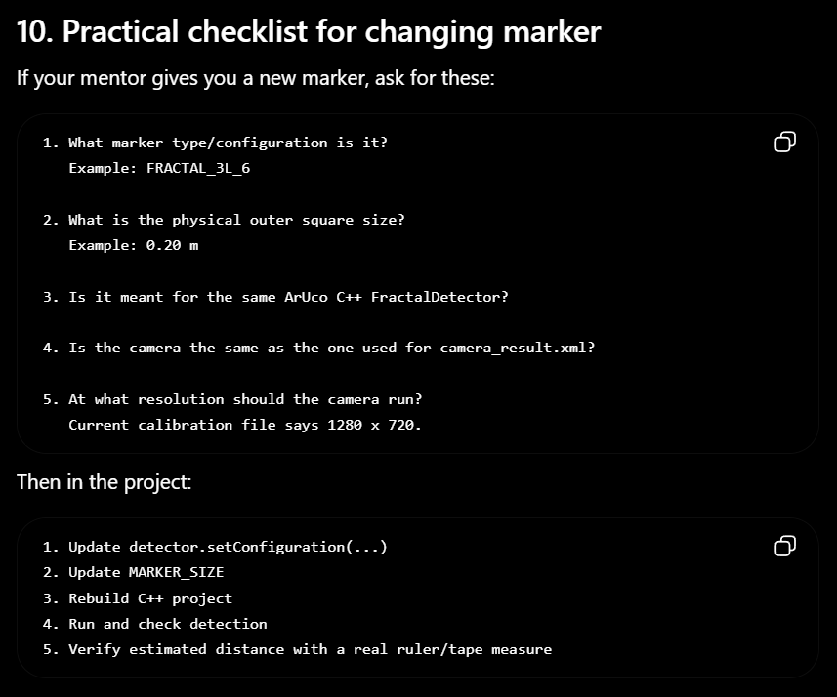
About changing and how to actually set the fractal marker to be detected.
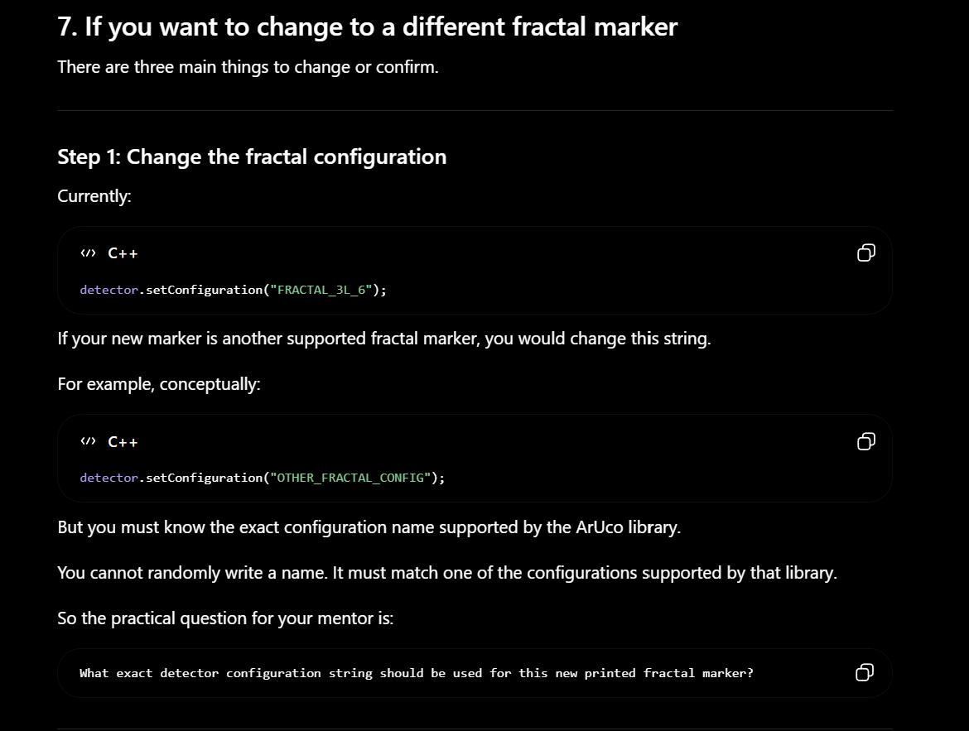

Checkpoint :
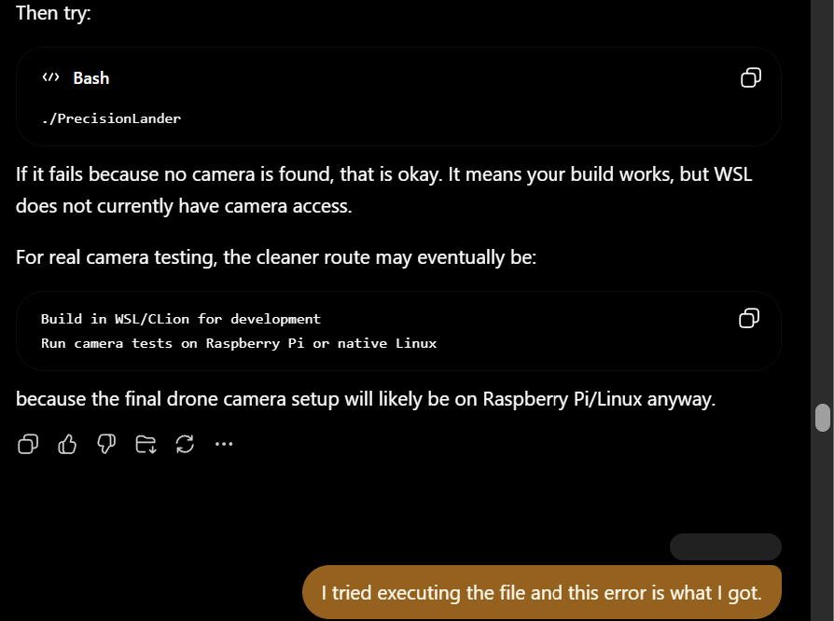

Project Timeline:
- Pose behavior validation -- Here
2. Pose accuracy validation
3. Fix marker size
4. Check / redo camera calibration
5. Add filtering and detection reliability logic
6. Confirm coordinate system
7. Prepare MAVLink landing target message
8. Connect Raspberry Pi to Pixhawk
9. Bench test without propellers
10. Mount camera/Pi on drone
11. Ground movement test
12. Low-altitude hover test
13. Final precision landing test
Current project timeline.
MAVLink comms. There are two approaches we can do.
Pose accuracy validation
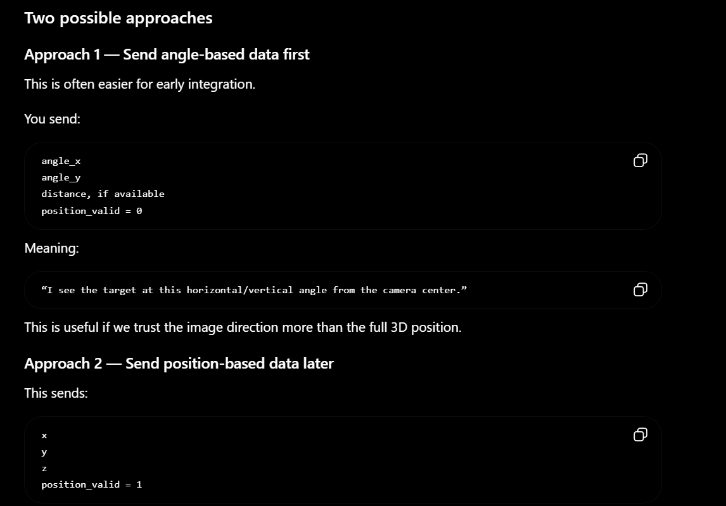
But right now I’m going with approach 1 and will continue to with second approach later.

Made some changes:
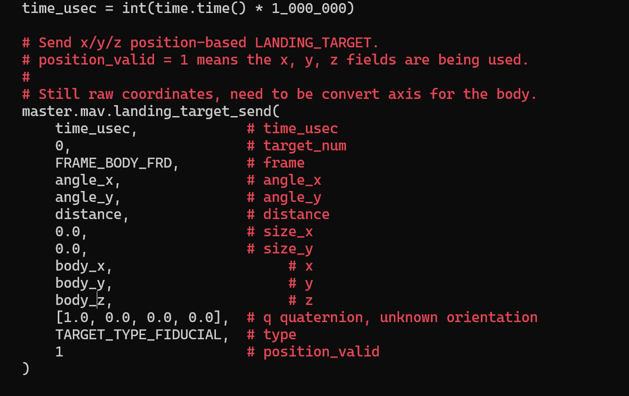Might be reversible, I have to change the log and print statement also If I change back body_x y z into xyz again.

Things I need to do,
- camera calibration prob and add some readme.md file for tutorial ig like the one in alex’s github

- Rasp pi mount on the left side of the drone shell. The camera mounted right below the rasp pi.
- Ada 2 mode. ( guided and land ). Because the camera definitely is not going to see the marker until the height is 0. So maybe baca documentation on till what height we can switch the mode from guided to land and the drone will go straight down. Prob like 50cm till 1 m. So the camera since it’s like on the left side, not really pointing straight down, I need to add offset to the formula and parameter.
Kalibrasi Camera
SITL buat simulator, tes dia punya koreksi gimana

Calibration cam

30cm :
Sent: x = 0.008m, y= -0.006m, z = 0.147m, Distance = 0.147m, angle_x = 3.153°, angle_y = -2.162° 0.008084 -0.005539 0.146739 0.147066 0.055035 -0.037733
0.008039 -0.005502 0.146398 0.146722 0.054855 -0.037567
0.002688 -0.001894 0.048743 0.048853 0.055081 -0.038829
0.008111 -0.005558 0.147119 0.147448 0.055073 -0.037761
0.008102 -0.005524 0.146916 0.147242 0.055089 -0.037582

50 cm:

Sent: x = 0.000m, y= -0.004m, z = 0.256m, Distance = 0.256m, angle_x = 0.093°, angle_y = -0.881° 0.000418 -0.003940 0.256273 0.256304 0.001631 -0.015372
0.000416 -0.003947 0.257161 0.257192 0.001617 -0.015348
0.000411 -0.003928 0.256157 0.256187 0.001603 -0.015334
0.000431 -0.003981 0.257062 0.257093 0.001677 -0.015487
0.000370 -0.003972 0.256409 0.256440 0.001444 -0.015489
Sent: x = 0.000m, y= -0.004m, z = 0.257m, Distance = 0.257m, angle_x = 0.093°, angle_y = -0.883° 0.000418 -0.003962 0.257132 0.257163 0.001625 -0.015408
0.000405 -0.003950 0.256890 0.256921 0.001575 -0.015375
0.000341 -0.003923 0.255576 0.255606 0.001336 -0.015348
0.000390 -0.003906 0.255001 0.255031 0.001528 -0.015318

80 cm:
Sent: x = 0.005m, y= -0.000m, z = 0.059m, Distance = 0.059m, angle_x = 4.544°, angle_y = -0.286° 0.004676 -0.000294 0.058825 0.059012 0.079316 -0.004991
0.004643 -0.000185 0.058794 0.058977 0.078811 -0.003147
0.004631 -0.000190 0.058825 0.059007 0.078570 -0.003229
Sent: x = 0.005m, y= -0.000m, z = 0.059m, Distance = 0.059m, angle_x = 4.509°, angle_y = -0.190° 0.004643 -0.000195 0.058887 0.059071 0.078689 -0.003318
0.004642 -0.000185 0.058858 0.059041 0.078711 -0.003148
0.004687 -0.000285 0.058834 0.059021 0.079491 -0.004850
0.010988 -0.000514 0.137973 0.138411 0.079468 -0.003727
Sent: x = 0.011m, y= -0.001m, z = 0.138m, Distance = 0.138m, angle_x = 4.554°, angle_y = -0.209° 0.010992 -0.000504 0.137994 0.138432 0.079486 -0.003654

1m :

Sent: x = -0.000m, y= 0.000m, z = 0.073m, Distance = 0.073m, angle_x = -0.167°, angle_y = 0.045° -0.000213 0.000057 0.073022 0.073023 -0.002917 0.000778
-0.000201 0.000055 0.073028 0.073028 -0.002746 0.000749
-0.000203 0.000056 0.073137 0.073137 -0.002772 0.000762
-0.000206 0.000056 0.073272 0.073273 -0.002814 0.000761
-0.000204 0.000057 0.073285 0.073285 -0.002784 0.000780
Sent: x = -0.000m, y= 0.000m, z = 0.073m, Distance = 0.073m, angle_x = -0.157°, angle_y = 0.052° -0.000201 0.000067 0.073289 0.073289 -0.002746 0.000910
-0.000207 0.000060 0.073324 0.073324 -0.002830 0.000818
-0.000191 0.000062 0.073470 0.073470 -0.002603 0.000846
-0.000185 0.000054 0.073585 0.073585 -0.002519 0.000738
-0.000176 0.000073 0.073462 0.073463 -0.002390 0.000999
Sent: x = -0.000m, y= 0.000m, z = 0.074m, Distance = 0.074m, angle_x = -0.150°, angle_y = 0.052° -0.000192 0.000067 0.073551 0.073551 -0.002616 0.000906
-0.000176 0.000070 0.073619 0.073619 -0.002394 0.000945
-0.000184 0.000066 0.073717 0.073718 -0.002494 0.000896
-0.000168 0.000068 0.073674 0.073674 -0.002284 0.000928
Sent: x = -0.000m, y= 0.000m, z = 0.074m, Distance = 0.074m, angle_x = -0.132°, angle_y = 0.052° -0.000170 0.000066 0.073724 0.073724 -0.002300 0.000899
-0.000178 0.000064 0.073648 0.073649 -0.002422 0.000869
-0.000167 0.000068 0.073736 0.073736 -0.002271 0.000920

